Story Response - Maximum Story Displacement

Summary Description
This is story response output for a specified range of stories and a selected load case or load combination.

Input Data
Name | StoryResp4
Display Type | Max story displ | Story Range | All Stories
Load Case | RS | Top Story | Story6
Output Type | Not Applicable | Bottom Story | Base

Plot
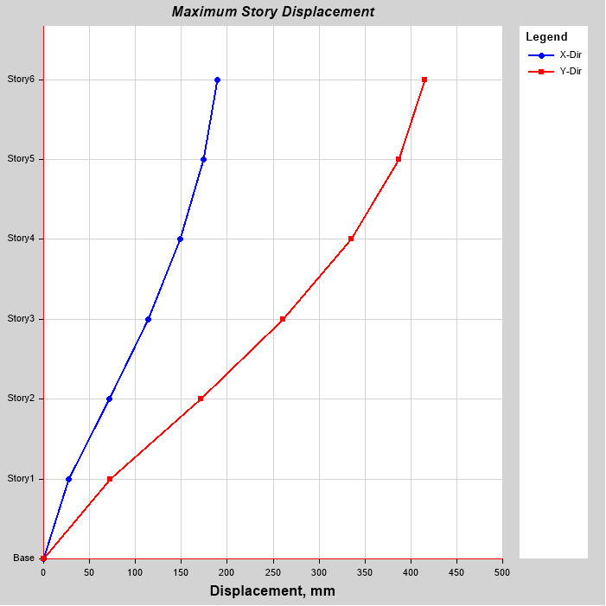

Tabulated Plot Coordinates

Story Response Values
Story | Elevation | Location | X-Dir | Y-Dir
 | m |  | mm | mm
Story6 | 18 | Top | 189.318 | 415.701
Story5 | 15 | Top | 174.504 | 387.248
Story4 | 12 | Top | 149.035 | 334.938
Story3 | 9 | Top | 113.712 | 261.229
Story2 | 6 | Top | 71.242 | 170.92
Story1 | 3 | Top | 27.261 | 72.172
Base | 0 | Top | 0 | 0

